Week 6:

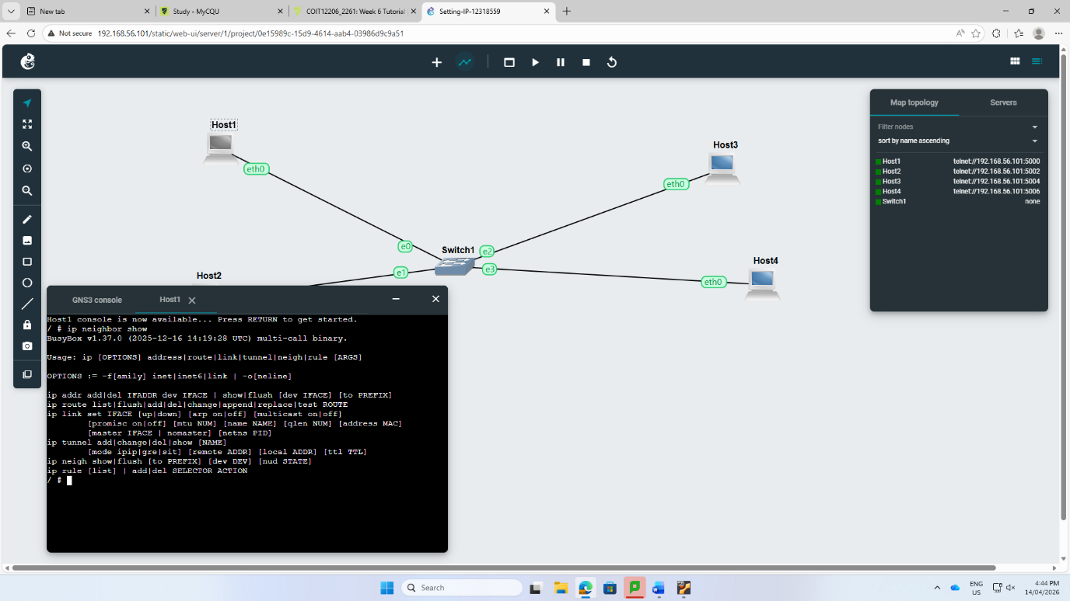
In week 6, the network containing 4 hosts and 1 switch was created and each host and switch was set up with the IP address manually. I tried to see the data using command ip neighbor show.

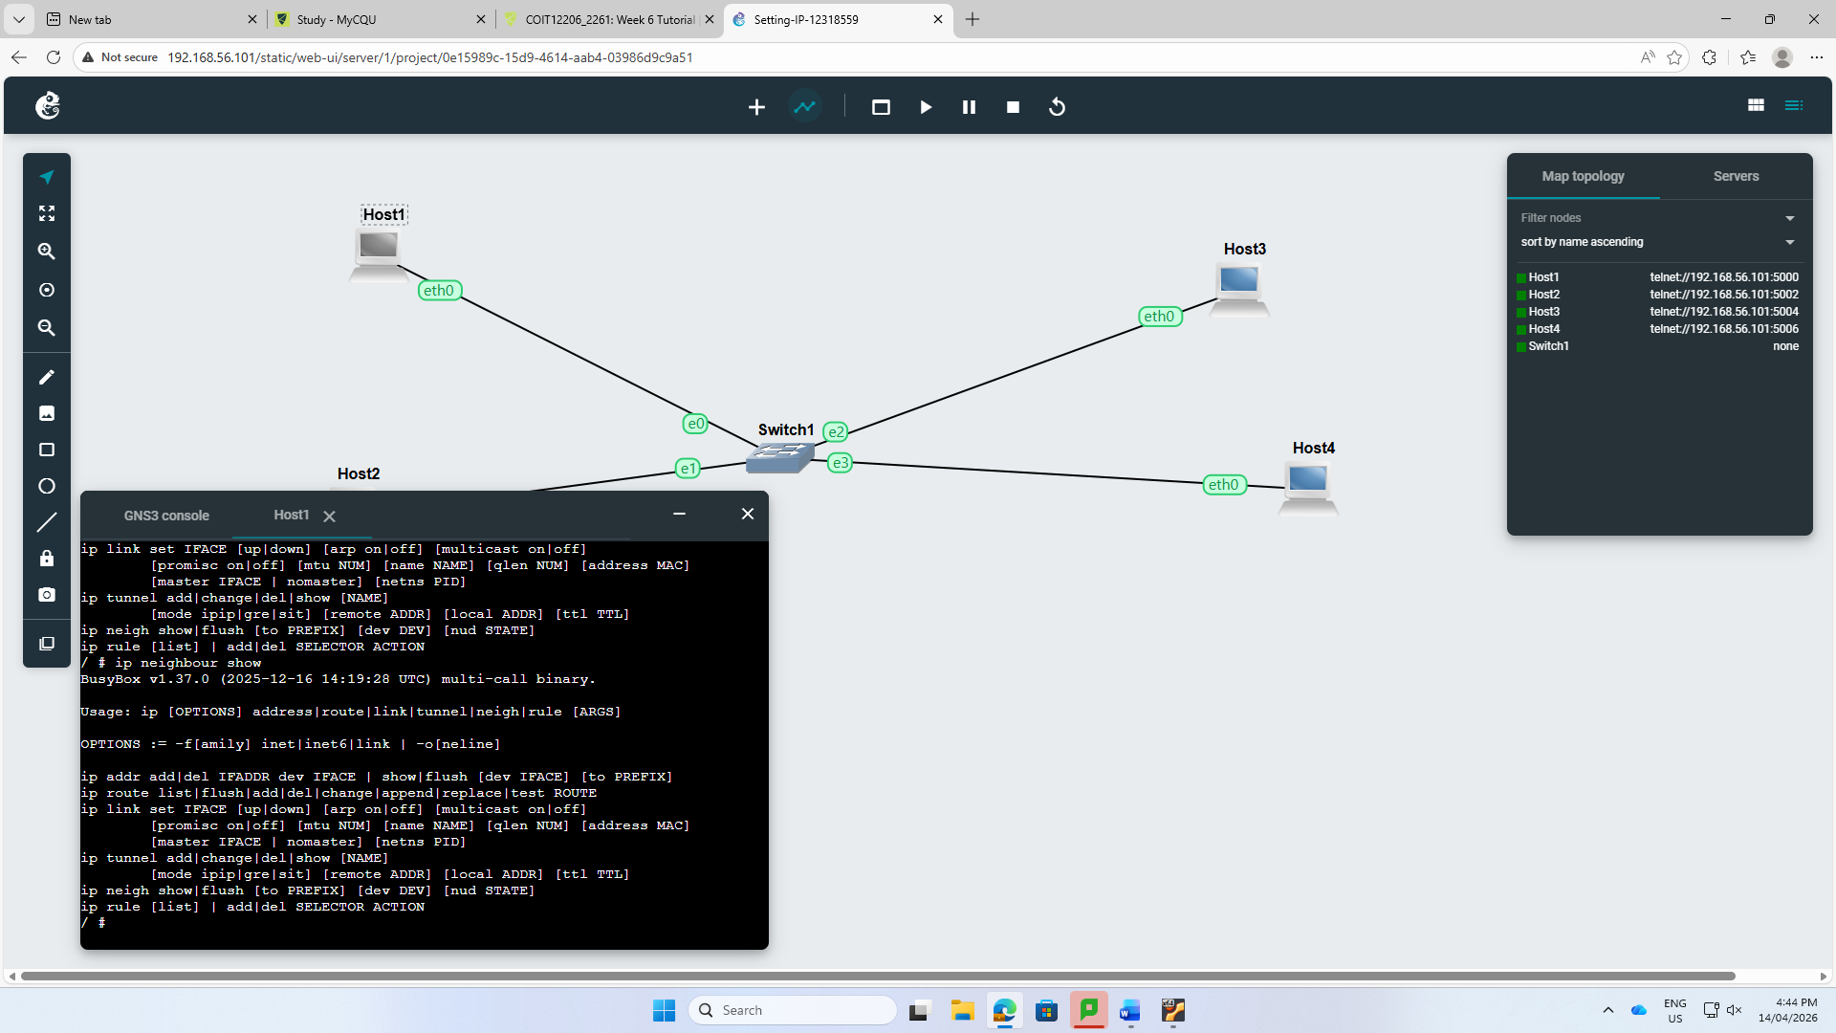
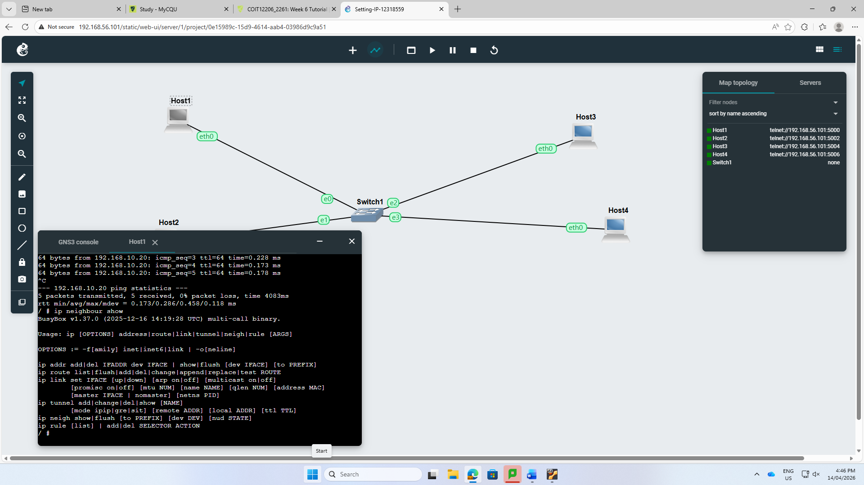
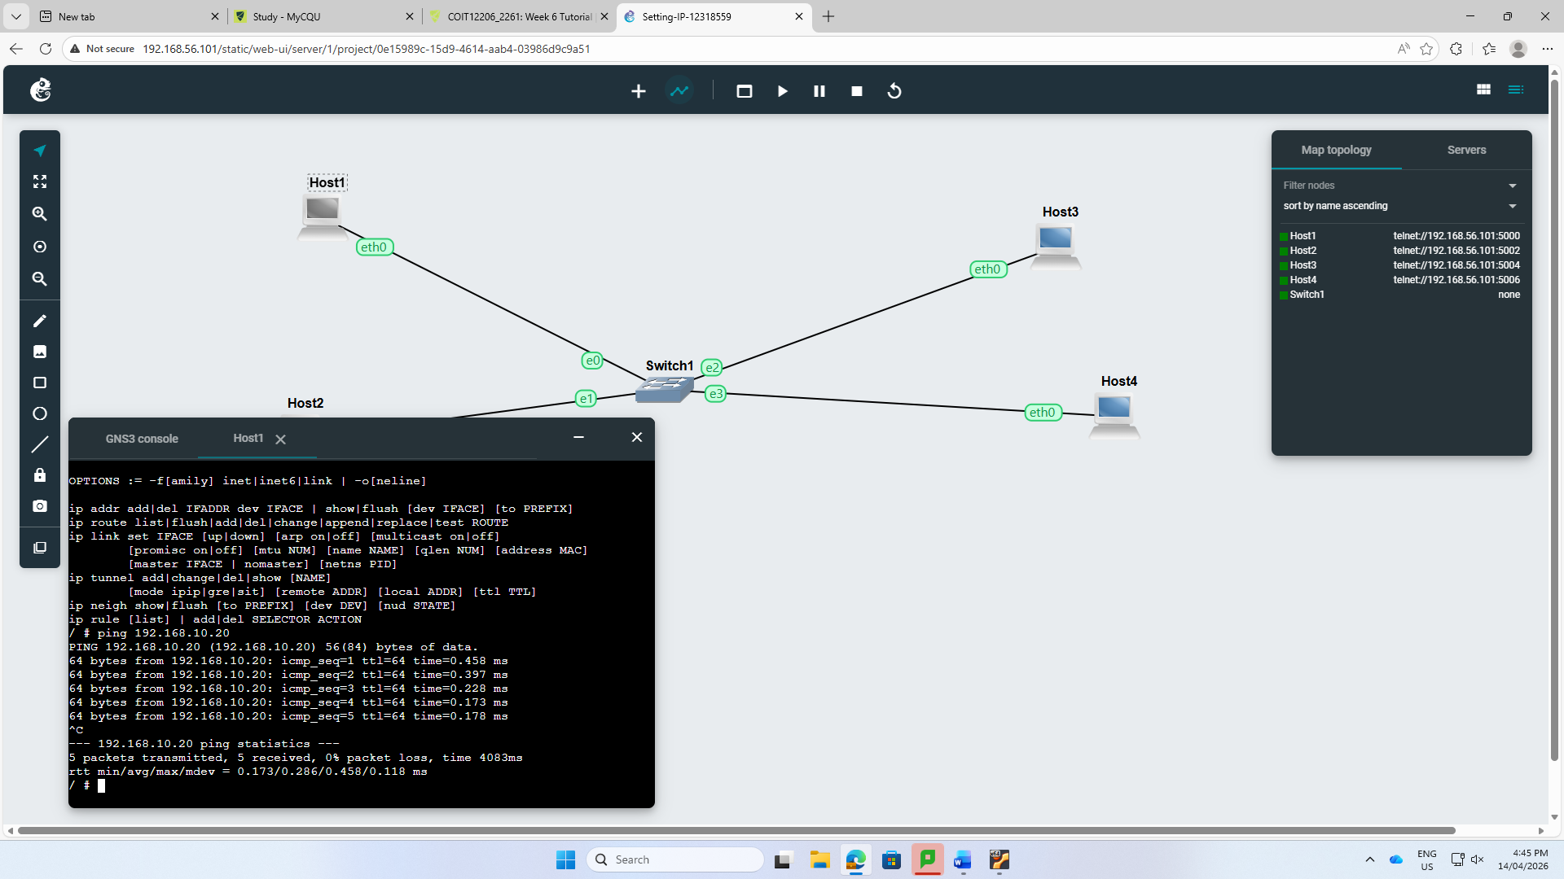

Step 2: I tried to ping one device to another and it was successfully pinged. Since, the ip addressing was alright.

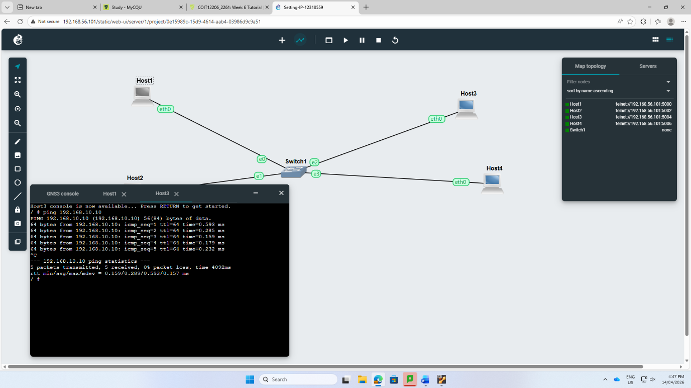
Then, I again use the command ip neighbor show to make a difference between above and new table.
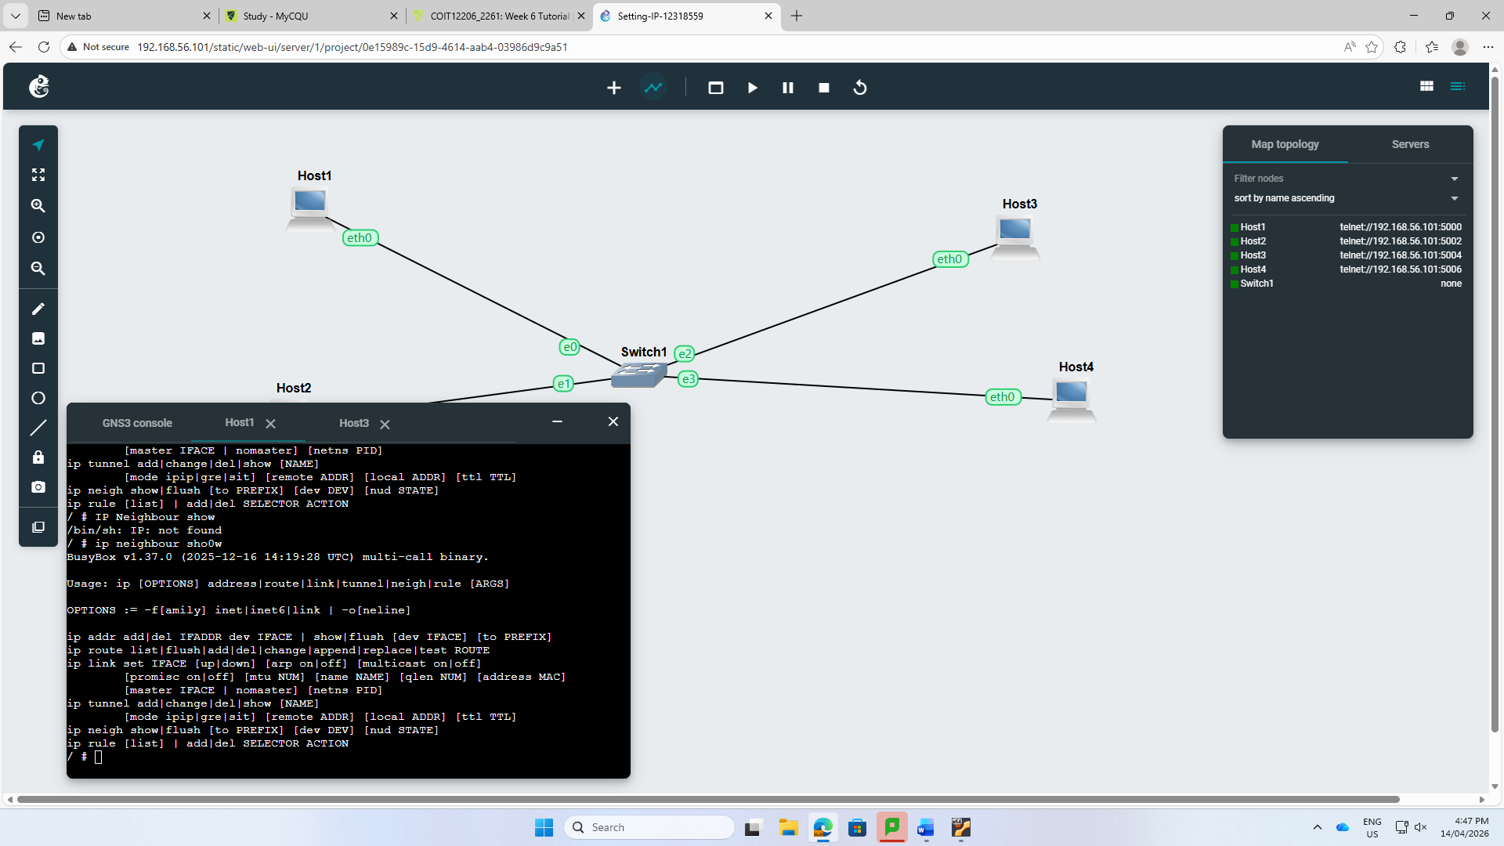

Part 2:
Step 1: I tried to set IP address and gateway manually. At first, it was showing error but afterward I put a command up sysctl net.ipv4.ip_forward=1, then it worked perfectly.

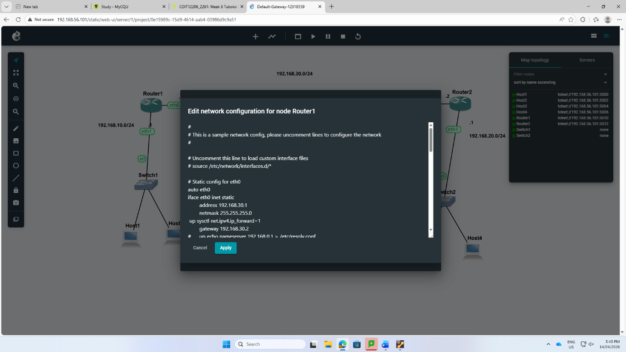
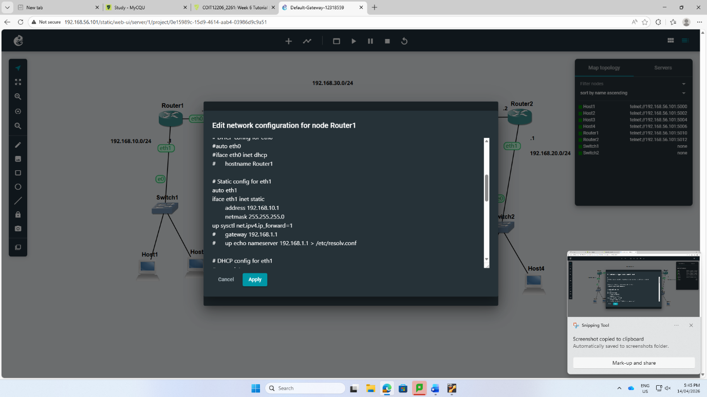

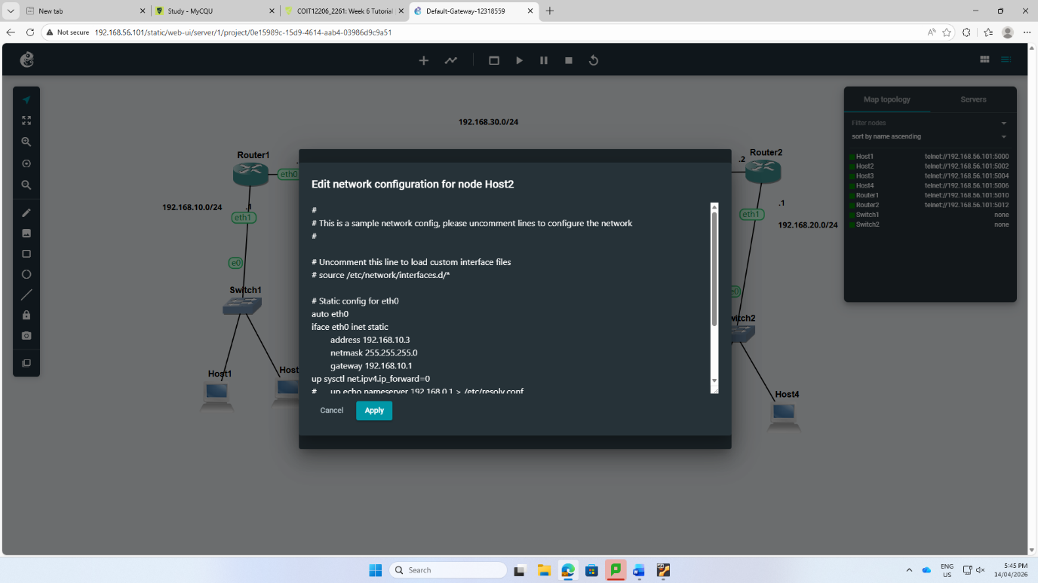
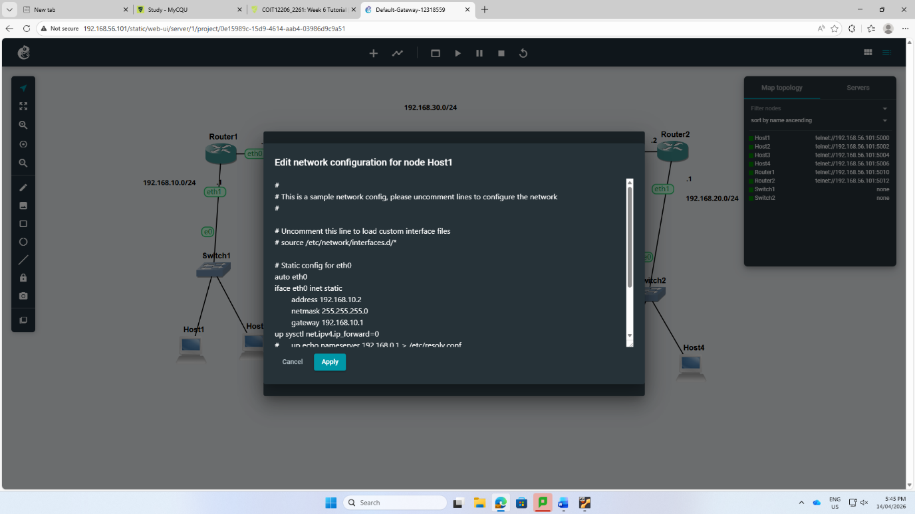

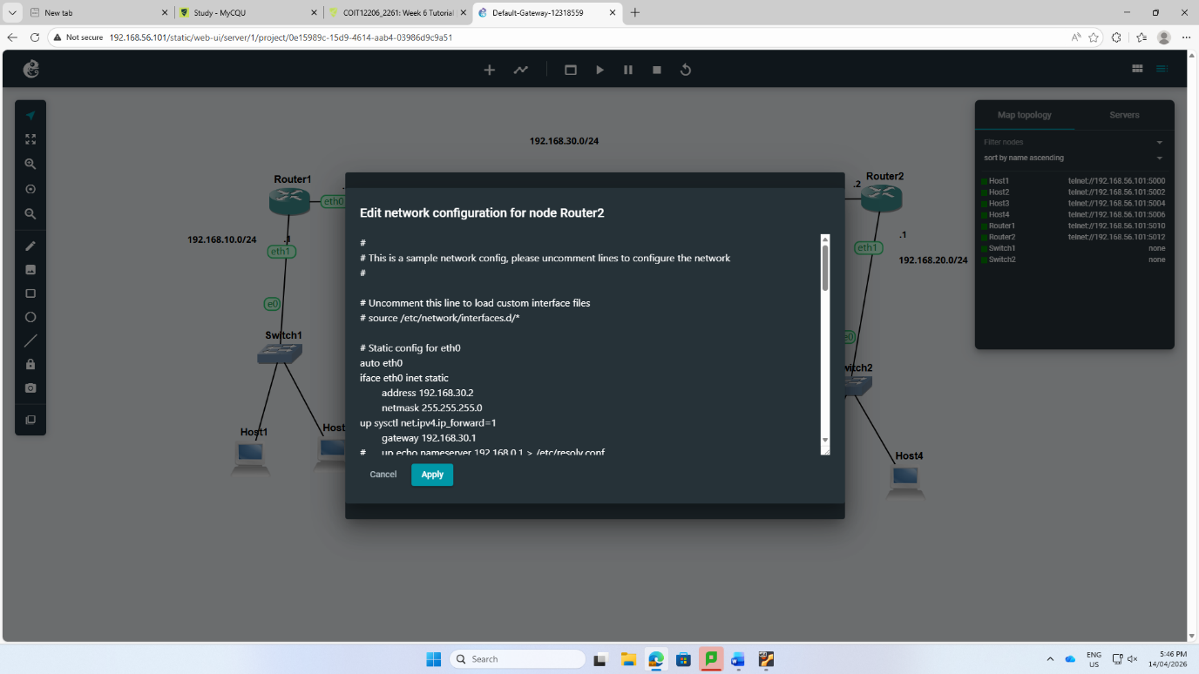
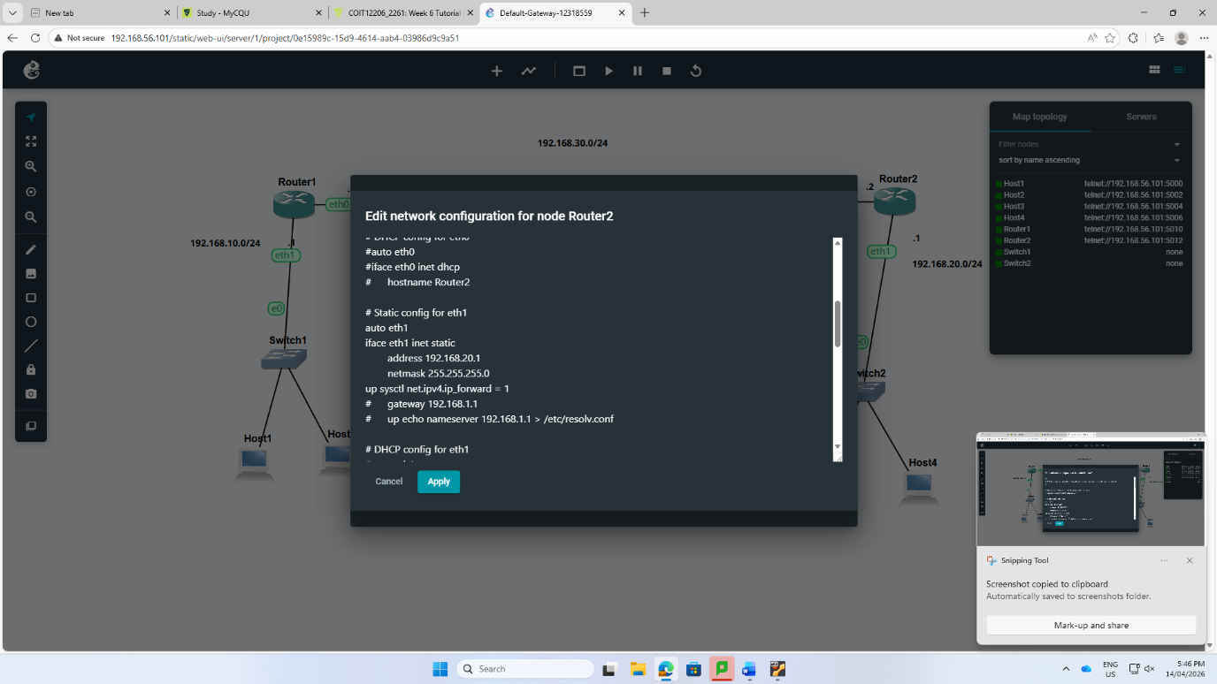

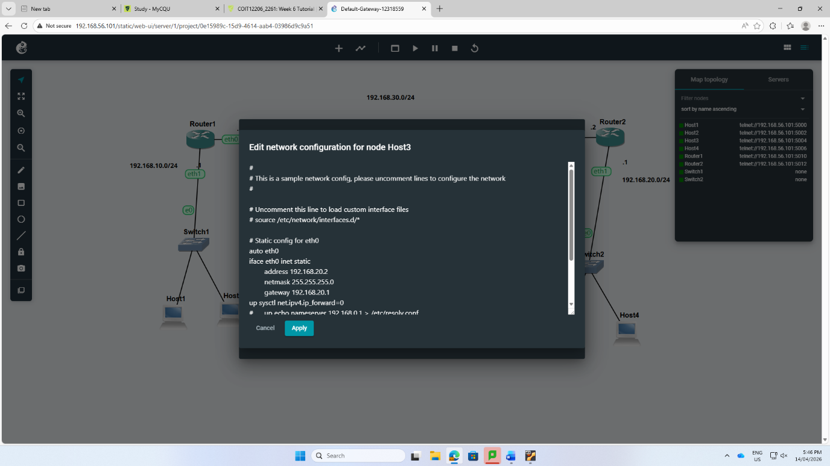
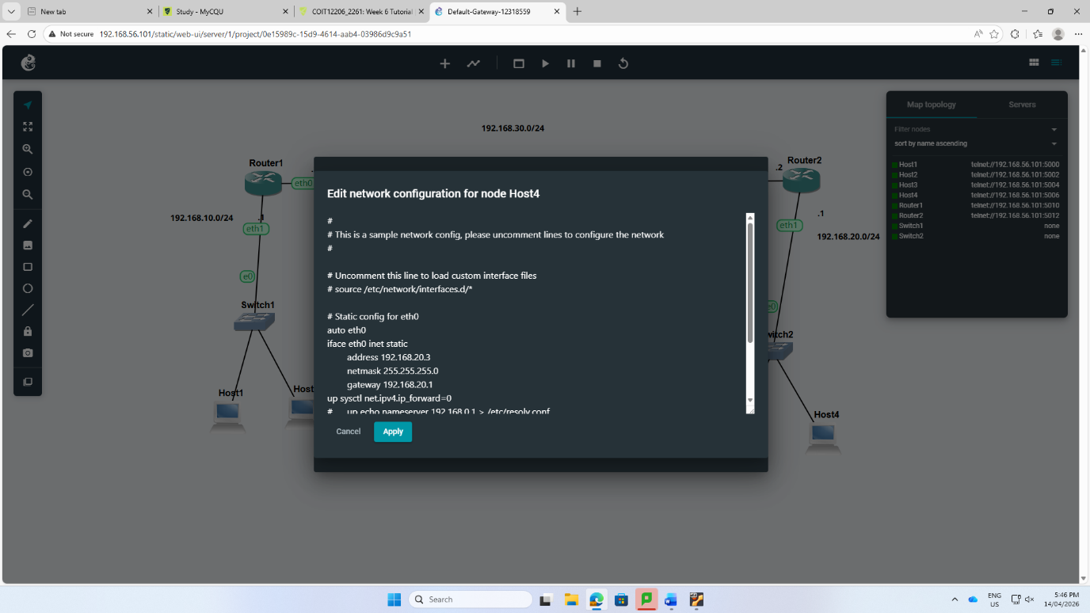
Step 3: The IP address for each host was set up manually. The IP address for each router for eth0 and eth1 were also setup properly such up sysctl net.ipv4.ip_forward=0 and up sysctl net.ipv4.ip_forward=1 individually.
Step 4: I tried to ping the host with router as well as different hosts that has different IP address and gateway but also it ran successfully.

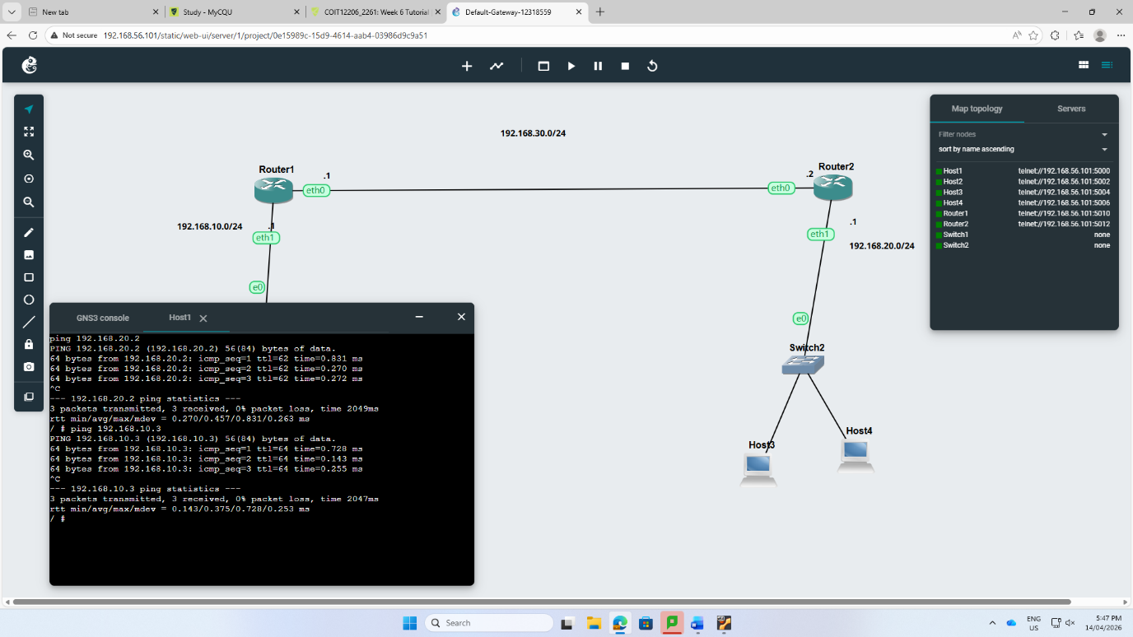
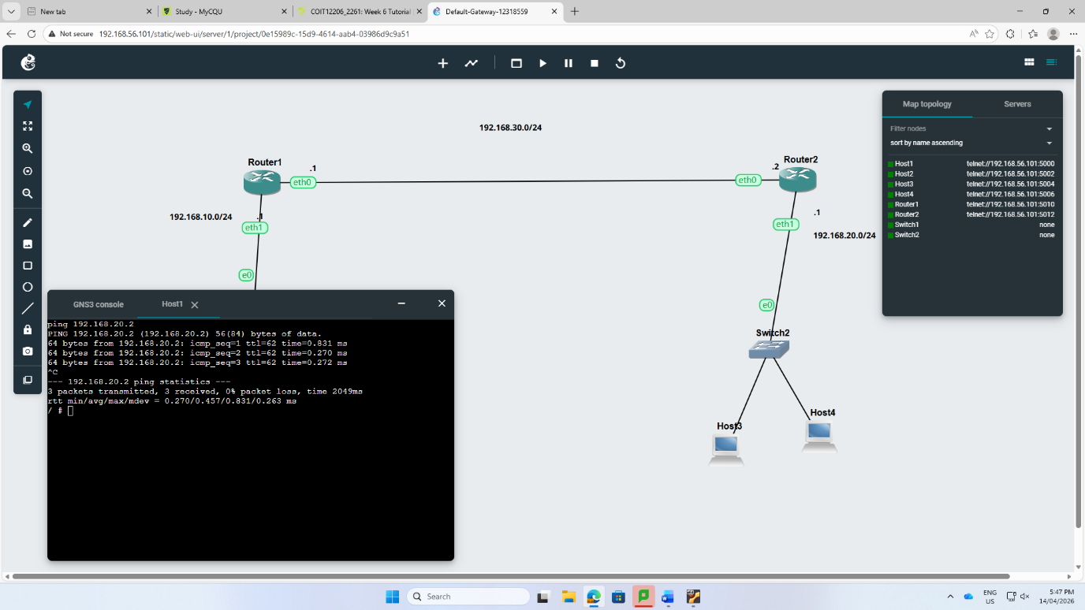

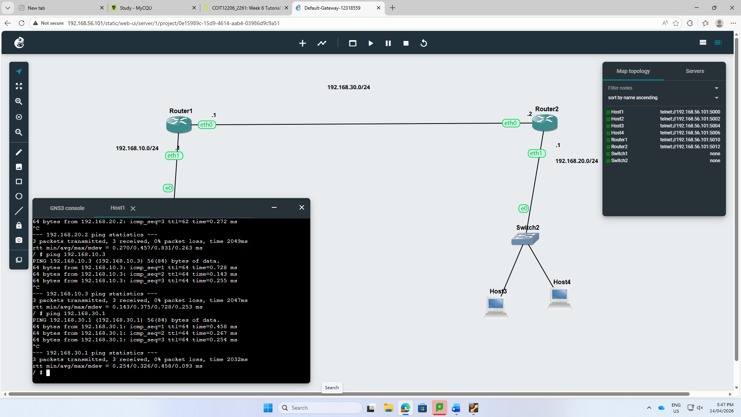
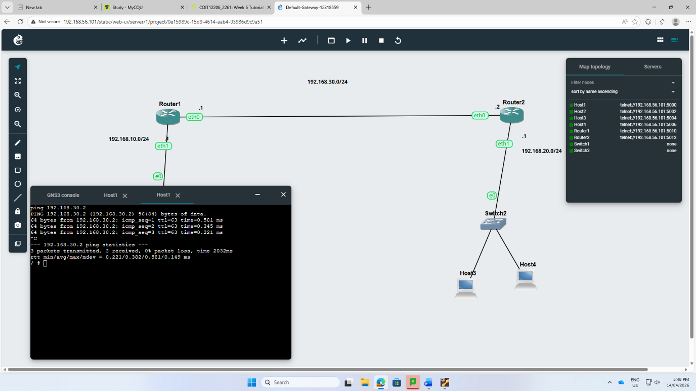

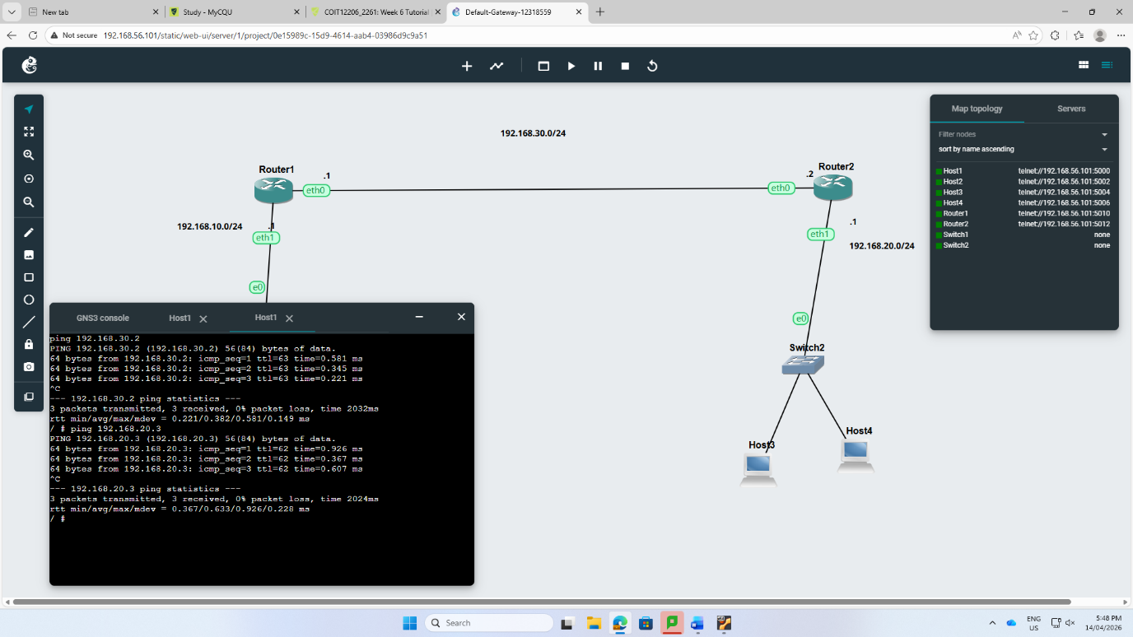
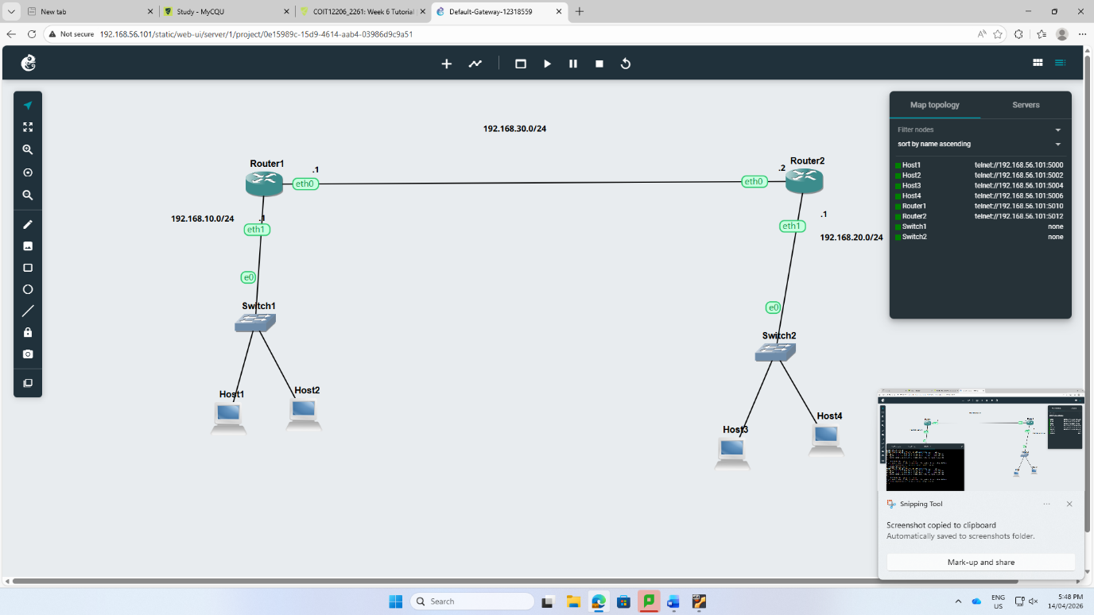

Reflection:
In week 6, I developed upon my past work using Inter-VLAN routing to sustain more hard network scenarios containing various subnets and logical segments. The use of Open vSwitch(OVS) was continued to manage controlled separation through VLAN10 and VLAN20 making sure the router is perfectly managing traffic along with virtual sub-interfaces. Through many testings, and a successful result made my confidence higher to fix connectivity errors. This tutorial helps me to understand the logic segmentation and the route of layer 3 combine together to establish productive, flexible and safe network surroundings.

